Exploring Quantitative Variables: IMDb Movie Reviews
Your Name: _______________
September 26, 2022


Learning outcomes
- Identify and create appropriate summary statistics and plots given a data set or research question for quantitative data.
- Interpret the following summary statistics in context: median, first quartile, third quartile, standard deviation, interquartile range.
- Identify and create appropriate summary statistics and plots given a data set or research question for a single quantitative variable.
- Given a plot or set of plots, describe and compare the distribution(s) of a single quantitative variable (center, variability, shape, outliers).

Terminology review
In today’s activity, we will review summary measures and plots for quantitative variables. Some terms covered in this activity are:
- Two measures of center: mean, median
- Two measures of spread (variability): standard deviation, interquartile range (IQR)
- Types of graphs: box plots, dot plots, histograms

Movies released in 2016
A data set was collected on movies released in 2020. Here is a list of some of the variables collected on the observational units (each movie):
Variable | Description
Movie | Title of the movie
averageRating | Average IMDb user rating score from 1 to 10
numVotes | Number of votes from IMDb users
Genre | Categories the movie falls into (e.g., Action, Drama, etc.)
2020 Gross | Gross profit from movie viewing
runtimeMinutes | Length of movie (in minutes)

Visualizing a Single Quantitative Variable
- What are the three types of plots used to plot a single quantitative variable?

Dotplot
A dotplot will plot a dot for each value in the data set. The code below was used to create a dotplot of the averageRatings variable from the movies dataset. In a dotplot, the quantitative variable goes on the x-axis, which is why the code says x = averageRating inside of the aes() function.
ggplot(data = movie_ratings,
mapping = aes(x = averageRating)) +
geom_dotplot(dotsize = 0.5) +
labs(title = "Score of Movies from 2020", # Title for plot
x = "IMDb Score", # Label for x axis
y = "Frequency" # Label for y axis
)
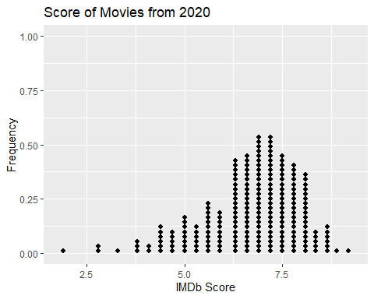
- What does each dot on the dotplot represent?
- How would you describe the shape of the distribution of IMDb scores?

Histogram
To create a histogram of the IMDb scores, all we need to do is change the geometric object we are displaying on our plot! In a dotplot we use dots, but in a histogram we use bars. Notice, in the code below there are two changes:
- I am using geom_histogram() instead of geom_dotplot()
- I am specifying how wide the bins of the histogram should be using binwidth = 0.6
ggplot(data = movie_ratings,
mapping = aes(x = averageRating)) +
geom_histogram(binwidth = 0.6) +
labs(title = "Score of Movies from 2016", # Title for plot
x = "IMDb Score", # Label for x axis
y = "Frequency" # Label for y axis
)
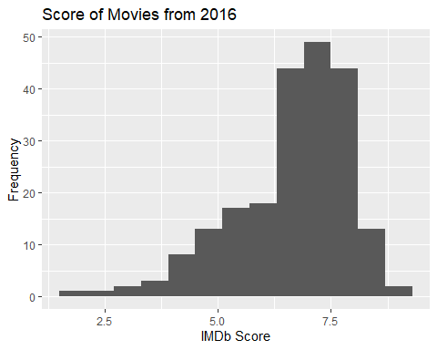
- Why did I not need to specify a binwidth in the dot plot I made?
- Which range of IMDb scores have the highest frequency?
- What IMDB scores are movies rarely rated?
- Are there IMDB scores that were possible but no movies in this sample were given those ratings?

Boxplot
- Which five summary statistics are used to create a box plot?

In the code below I’ve provided you with all of the statistics you listed in #7.
summarize(movie_ratings,
min_score = min(averageRating),
Q1_score = quantile(averageRating, 0.25),
median_score = median(averageRating),
Q3_score = quantile(averageRating, 0.75),
max_score = max(averageRating)
)
## # A tibble: 1 x 5
## min_score Q1_score median_score Q3_score max_score
## <dbl> <dbl> <dbl> <dbl> <dbl>
## 1 1.9 6.1 7 7.6 9.2
- Using the summary statistics provided, sketch a box plot of IMDb scores. Be sure to label the axes!
- How do you decide if a value is an “outlier” when creating a boxplot?
In the code below, I’m providing you with the top 3 and the bottom 3 IMDb scores.
Bottom 3:
movie_ratings %>%
select(averageRating) %>%
slice_min(order_by = averageRating, n = 3)
## # A tibble: 3 x 1
## averageRating
## <dbl>
## 1 1.9
## 2 2.7
## 3 2.9
Top 3:
movie_ratings %>%
select(averageRating) %>%
slice_max(order_by = averageRating, n = 3)
## # A tibble: 6 x 1
## averageRating
## <dbl>
## 1 9.2
## 2 8.9
## 3 8.7
## 4 8.7
## 5 8.7
## 6 8.7
- Revisit your previous boxplot to decide if any observations should be plotted as outliers.
(Modify your previous plot)

Plot Comparison
- Compare the three graphs of IMDb scores created above.
- Which graph(s) show the shape of the distribution?
- Which graph(s) show the outliers of the distribution?
- Which graph plots the raw data (individual observations)?

Summarizing a single quantitative variable
- Based on the distributions provided, do you believe the mean IMDb score will be greater or less than the median? Explain why!
In the code below I’ve calculated the standard deviation of the IMDb scores.
summarize(movie_ratings,
sd_score = sd(averageRating)
)
## # A tibble: 1 x 1
## sd_score
## <dbl>
## 1 1.25
- Interpret the value of the standard deviation in the context of these data.

Take-Home Messages
- Histograms, box plots, and dot plots can all be used to graphically display a single quantitative variable.
- The box plot is created using the five number summary: the minimum value, Q1, median, Q3, and the maximum value. Values in the data set that are less than $Q_{1}-1.5*\text{IQR}$ and greater than $Q_{3}+1.5*\text{IQR}$ are considered outliers and are graphically represented by a dot outside of the whiskers on the box plot.
- Data should be summarized numerically and displayed graphically to give us information about the study.
- When comparing distributions of quantitative variables we look at the shape, center, spread, and for outliers. There are two measures of center: mean and the median and two measures of spread: standard deviation and the interquartile range, $\text{IQR}=Q3-Q1$.

